**Achievement Standard 91370 Supporting Evidence**

**Data integrity procedures**

The content and images for my website is student work that has been created by the students for their Media Studies Assessment.

Before forwarding the student work on to me for inclusion in to my website, my client has checked all articles and videos for relevance, accuracy and reliability.

**Legal, ethical and moral responsibilities**

As I have identified above, the content and images for my website have been created by students’ and checked by my client (teacher). This information is all original so there is no breach of copyright and/or Intellectual Property laws. The students’ have agreed that their work can be uploaded to my website and ultimately to be published online by my client; therefore there is no breach of privacy.

My client has checked the students’ work/submissions to ensure that no offence has been made against people’s values, ethnicity and religious beliefs.

It is the intention of my client to publish this website in the near future. He has yet to enable a provider for this to happen.

He is also considering creating a YouTube channel for the videos to be uploaded privately and the website will have them embedded.

**Advanced Photoshop Features**

This is my Banner:



These are the blending options I applied around the text: Stroke, Inner shadow, and Drop shadow. And the opacity of the blends is at 80%.

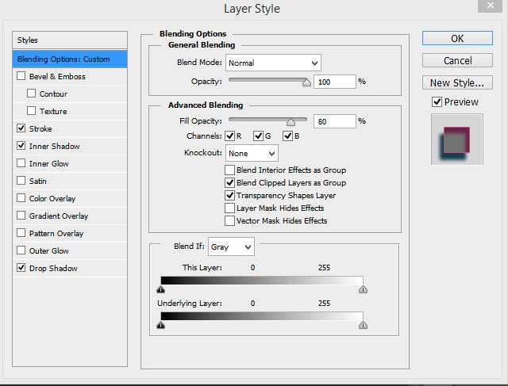

And the blends in the layers panel as well as the optimization.

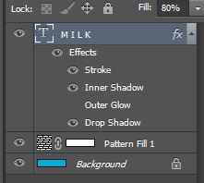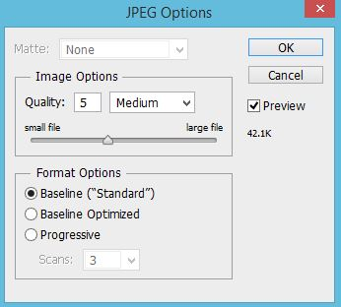

**Update:**

Original Image vs newly edited image:

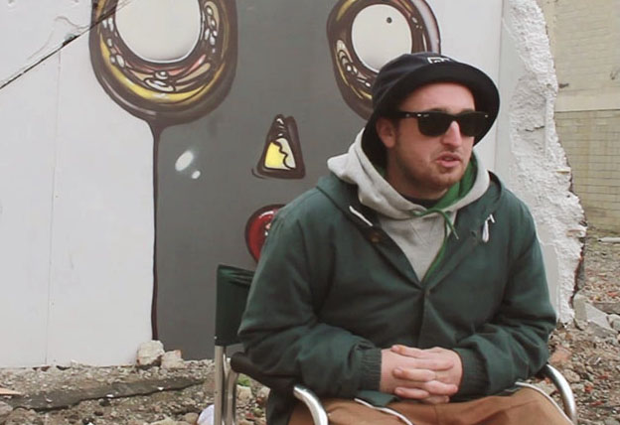

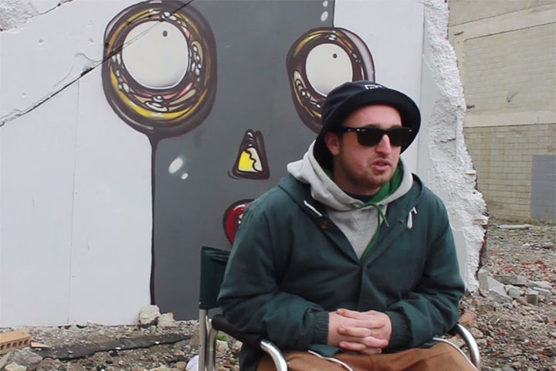

I chose to make the image warmer and a closer shot of the figure. I think this would work well with tone of the website and it’s pastel colours.

Layers (showing I changed the hue/saturation, vibrancy, and colour balances):

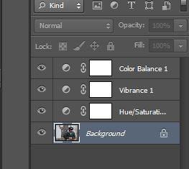

Optimization:

